KOMTECH 2017 - Guidelines for Authors

Title of paper (12 PT)

Andrew Author, Brian Author, Carol Author – Institute of Mining Technology (11 pt)

Abstract: This document provides information and instructions for preparing a paper to be included in the conference monograph (range 15 lines – 11 pt).

1. Introduction

All the participants that register their article are kindly requested to submit the full paper via e-mail at: aokulinska@komag.eu. The submission of the paper is not mandatory but highly recommended as it will be included in the ISBN Conference Monograph (on CD-ROM).

2. General

The preferred volume of the paper including illustrations: minimum 12 pages of the A4 size (20000 characters). Please do not count (number) pages. The text should be edited in MS Word (Arial 11, paragraph: 1 line spacing, margins: 2,5 cm. Title: 12 pt, bold.

3. Figures

All figures should be centered, numbered consecutively and captioned. The caption title – 10pt.

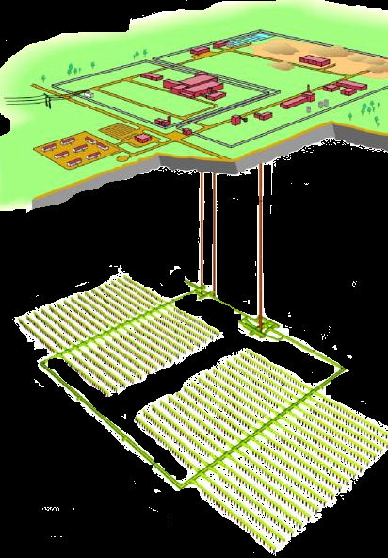
Fig.3. Example of the caption title

4. Equations

A displayed equation is numbered, using Arabic numbers in parentheses. It should be centered, leaving a 6 pt space above and below to separate it from the surrounding text.

The following example is a single line equation:

Ax = b | (1)
The next example is a multi-line equation:
Ax = b | (2)
Ax = b

5. tables

All tables should be centered, numbered consecutively and captioned, the caption should be 10 pt - bold.

Example of the construction of one table
Table 1

No. | Wyszczególnienie | Dopuszczalne graniczne  wartości wymywania
1. | Antymon | 0,06
2. | Arsen | 0,5
3. | Bar | 20

6. Conclusions

The papers will be published in a form of reviewed monograph. The condition of publishing the paper is to pay conference fee or to pay publishing fee – 80 EUR.

Provided time for paper presentation: 15 minutes

Bibliography
1.
2.
3.
(in Alphabetical order)

